THE BOMBAY THEOSOPHICAL BULLETIN
THE OFFICIAL JOURNAL OF
THE BOMBAY THEOSOPHICAL FEDERATION

Volume 91 |  | No.11 |  | Aug - 2022

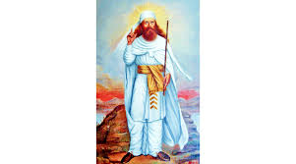

“One need not scale the heights of the heavens, nor travel along the highways of the world to Ahura Mazda. With purity of mind and holiness of heart one Cn find Him in one’s own heart.”

Zoroaster

MISSION OF TS
To serve humanity by cultivating an ever deepening
understanding and realization of the Ageless Wisdom,
spiritual self-transformation and the unity of all life
CONTENTS
Quote on Zoroastrianism | Cover
127th Indian Section Convention at Varanasi | 2
Guidelines for Membership Renewal Request | 3
Bro. Vinayak Pandya for IC at Naarden | 4 - 7
Asala Purnima Celebration at Blavatsky Lodge | 7 - 8
Birthday Message of Sis. Manorama Saxena | 8

Resolution by Indian Section TS Circulation
for 127th Indian Section Convention 2022

Dear Brother/Sister,
I have just learnt that the Registration for International Convention 2022 at Adyar is going to be limited to about 250 delegates only. Keeping in mind this emergency situation and to give an opportunity to all Indian Section members to attend our Indian Section Convention, the Executive Committee in its meeting held on 05-07-2022 has unanimously resolved to conduct the Indian Section Convention 2022 at Varanasi on 28-30 October 2022.
Members of the Indian Section Council are requested to ratify this decision of the Executive Committee by email reply before 10th July 2022.
With fraternal regards,
Pradeep Gohil
President, Indian Section of Theosophical Society
********************************************************************
Acting Editor – Sis. Mahazaver Rustom R. Dalal Cover Page by: Sis. Kashmira Khambatta Editorial Committee –Sis.Mahazaver Dalal (Reporter & in charge of Mailing List), Sis. Kashmira Khambatta, Sis. Aban Patel and Ex-Officio: President Bro. Vinayak Pandya. Note: News, Notes and Programs to be printed in the Bulletin be forwarded by e-mail to kashmira.khambatta@gmail.com latest by16th each month. Readers’ Views are invited.
Brethren of Bombay Theosophical Federation
It is time to request
President Shri Pradeep Gohil
Indian Section Theosophical Society, Varanasi
for Renewal of TS Membership
Both – Ordinary and Life Membership
Between 1st July to 30th September 2022
Only with E-mail to:
renewalindsecmem@gmail.com
In following format:
“I would like to continue my membership in the Indian Section of the Theosophical Society”
with
- Member’s Name (2) Name of Lodge (3) Diploma No.
(4) The Indian Theosophist Required: Yes/No English/Hindi
(5) Signature and (6) Date
For Bombay TF Records copy your e-mails to:
BTF Secretary Sis. Mahazaver Dalal; mahazaver@hotmail.com
BTF Treasurer Bro. Taral Munshi: taral.munshi@gmail.com
If you need help, contact your Lodge Officers or
BTF Secretary Sis. Mahazaver Dalal (M):+91-9833131216
***************************************************
Please Note:
According to Indian Section TS Amended membership Rules now there are no Annual Dues, no Admission Fees & no Life Membership Dues of Indian Section TS. Indian Section Life Membership is now only of who had become Life Member up to Year 2019-2020.

At Lodge Level there is no Life Membership. Lodge Life Membership is now converted into Ordinary Membership. Hence current members pay Lodge Fees and New Members in addition to Lodge Fees pay Admission Fees of Lodge and BTF.
TS Membership is confirmed only when Membership Revival Request for the next year is e-mailed as above to ISTS in time.
Associate Members have to send e-mail
from their Mother Lodge Only.
MEMORIES OF GENERAL COUNCIL MEETING
FOR STRATAGIC PLANNING AT INTERNATIONAL THEOSOPHICAL CENTER AT NAARDEN IN NETHERLAND FROM 10 JUNE TO 13 JUNE 2022
BY VINAYAK PANDYA
International Council Member & President Bombay TF

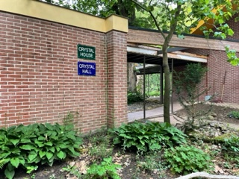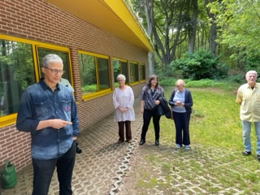

Ever since Mr. Tim Boyd has taken over responsibilities of International Presidentship of Theosophical Society (TS), he has been making every attempt to resurgent TS. As part of this it has been decided to have General Council (GC) Meetings twice in a year. TS has wonderful centers at many places. One of this is International Theosophical Centre (ITC) at Naarden in Netherlands. This centre is on 15 acres of lush green forest land. It is a wonderful centre with Besant Hall, Crystal House, Crystal Hall, Lotus House, St. Michal House, Garden of remembrance, Catholic Church, Cottages, Round Table and other facilities. GC meeting was held here for strategic planning of TS at Besant Hall. Many GC members along with invitees were present in person and online Zoom Platform at the meeting. Participants were expected to arrive on 09 June and leave on 14 June 2022.

Mr. Tim Boyd presided over the meetings. President welcomed everyone and Meeting began with silence & invoking masters to guide the TS. The purpose of the meeting was to critically evaluate what we have been doing? What is to be done? How to make the TS more effective in future? Mr. Tim Boyd explained the need of this meeting. He reviewed what has been going on in TS work and what changes are needed. He also outlined 40 projects members should think over to do. There is no hurry, but we have to take call on one or other day.

Introductory Book on Theosophy:-
Matter was discussed at it was concluded that various sections have books on introduction of Theosophy, and it should be shared amongst other sections, who need it.

Social Media:-
Brother Vicente Hao Chin Jr presented paper on use of social media. He emphasized that TS should allocate more budget for this. He also emphasized that technical persons should be hired for this work. He said TS should have their presence on Facebook, Tweeter and other social media. Every day something should be posted.

Damodar Gardens:-
President Mr. Tim Boyd informed the members that Krishnamurthy Foundation of India (KFI) have vacated the Damodar Gardens (DG) on 30 May 2018. Now deal has been finalized for leasing this property for school with Shiv Nadar Trust. It took longer period due to Covid Pandemic and unforeseen circumstances. Now it has been executed. It will generate revenue to TS.

Theosophical Schools:-
Members were informed that Adyar Theosophical Academy was started with 22 students of KG to Grade 2. Every year it adds class. Accordingly, infrastructure is also developed to accommodate increase in Classes.

Theosophy World:-
Mr. John from New-Zealand explained Theosophical World. An exhaustive work is done on Theosophy World. Most of the TS literature is available on this site. Members/ anyone can visit this site & get knowledge on TS. It was discussed how to utilize fully the efforts made in New Zealand for TS at large.

Theosophical Centre at Brazil:-
Brazil section thanked for help from other TS centers for acquiring and finalizing their deal for 376 Acres of land with 21 springs and other natural resources. It will help a lot to pursue Theosophy at large. The video showing property can be seen on the link.https://youtu.be/jDCbkwIVISI

World Youth Theosophical Federation:-
It was decided to restart Youth Theosophical Federation. Elections will be done to elect office bearers. Members up to the age of 40 will be in youth Theosophical Federations.

International Youth Convention from 27 to 29 December 2022(3 days) at Adyar:-
It was decided that International Youth Convention will be held from 27 to 29 December 2022 at Adyar for age up to 40 years.

International Convention from 31 Dec 2022 to 04 Jan 2023:
TS international convention will be held at Adyar from 31 December 2022 to 04 January 2023.This convention will be restricted to 250 delegates in person. Leadbeater Chambers is ready for occupation. New Quadrangle building is under renovation. Due to these accommodations will be reduced substantially. Members are requested to attend either in person or online. Those members who can’t attend physically; they should send their registration for online. This will create link in convention work, it will have contribution for master’s work. There are lot of infrastructure changes taking place at Adyar. Now a days live telecast is available.

Indian Section Convention Traditionally Indian Section convention is always held along with International convention. This year due to major repair work at Adyar for Indian residential premises, no of
delegates will be restricted at Adyar. In view of this Indian Section convention will be held on 28 to 30 October 2022 at Varanasi, headquarters of Indian Section. Lodging & Boarding will be free. Registration should be done online by email. Registration fees to be deposited in Bank of Baroda. The details will be published in BTF journal.

There were fruitful deliberations with brainstorming at Naarden. It was a wonderful experience to be in Naarden to participate in General Council Meeting of the Theosophical Society.

I also visited Toronto Theosophical Lodge. It has a nice building which library, meeting hall, parking space and many other facilities. They conduct in person meeting fortnightly on Tuesdays and online fortnightly on Fridays. It was wonderful to meet fellow theosophist at Toronto including our own Sis. Aban Amroliwalla. Thanks to her, I was able to attend Toronto Lodge meeting and meet fellow Theosophists.

***************************************************
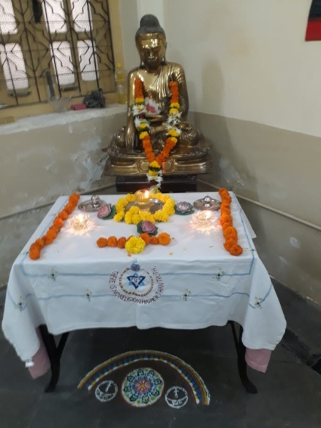 | ASALA PURNIMA MEETING  At Blavatsky Lodge, Mumbai  On Wednesday 13th July 2022  Six members braving onslaught of Guru Purnima Rains met in Green Room near the Alter prepared by Sis. Navaz Dhalla with flowers, Diya & Rangoli near Lord Buddha’s Statue.  Their number though small was significant. When Lord Buddha to his Five Disciples gave his First Sermon on -
‘The setting in Motion of the Royal Chariot Wheels of the Kingdom of Righteousness’ they were six in number.
Blavatsky Lodge VP Bro. Navin Kumar welcomed Brethren and opened the meeting with chanting of Hindu Prayer. The Prayers of other Religions were recited by Bro. Arni Narendran, Sis. Dr. Rajam Pillai, President Sis. Kashmira Khambatta, Sis. Navaz Dhalla and Bro. Rustom Cooper. The readings were from the Booklet on ‘Asala Purnima’ compiled by Late Sis. Khorshed Avari: Sis. Navaz – Significance of Asala Festival; Sis. Kashmira – The First Noble Truth – ‘Sorrow or Suffering’; Bro. Navin Kumar – The Second Noble Truth – ‘The Cause of Sorrow’; Bro. Rustom – The Third Noble Truth – ‘The Ceasing of Sorrow’; Sis. Navaz - the Fourth Noble Truth – ‘The Escape from Sorrow – The Eightfold Path’; Sis. Rajam – Translation of Buddhist Prayer and all together recited the Buddhist Prayer. The meeting had ended with Bro. Arni conducting meditation invoking the Blessings of Lord Buddha.

***************************************************
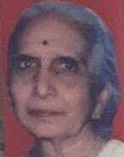  Mother of  Bro. Navin Kumar | Pearls from Diary of Centurion Theosophist  Sis. Manorama Saxena  As her Birthday Message  *Suffering is both a reminder and a guide. It stimulates us better to adapt ourselves to our environmental conditions, and thus leads the way to self-improvement.  *Grief and sorrows do not come to us by choice. They are sent to us by Divine Mercy for our own perfecting.

*******************************************************************
Price Rs.1/- Annual Subscription: Rs.10/-
*******************************************************************
Bombay Theosophical Federation, c/o Blavatsky Lodge, 7 – French Bridge, Chowpatty, Mumbai – 400 007. (Tel: 23685026) and printed at Vijay Copy Centre, 48/A, Saidunnisa Building, Sleater Road, Opposite Grant Road Station (West), Mumbai-400 007.

